20103153_Avni_arora_B6

1)

#include <iostream>

using namespace std;

template<class T1,class T2>

void add(T1 num1,T2 num2)

{

cout<<"\nSum="<<num1+num2<<endl;

}

int main()

{

int num1,num2;

float n1,n2;

cout<<"\nEnter integer values: ";

cin>>num1>>num2;

cout<<"\nEnter decimal values: ";

cin>>n1>>n2;

add(num1,num2);

add(n1,n2);

add(num1,n1);

return 0;

}

Output

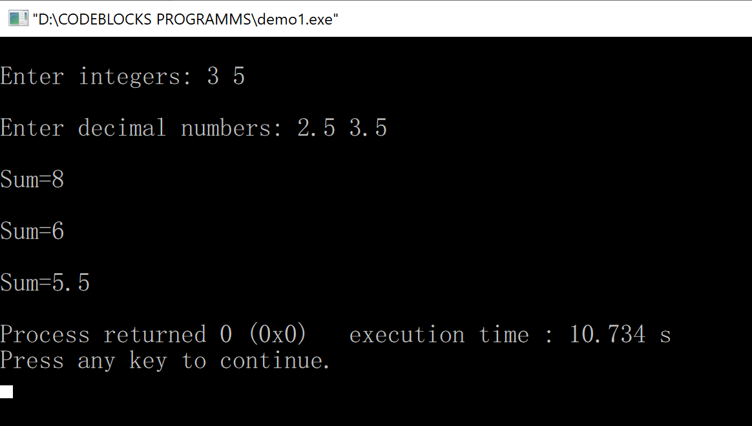

2)

x = 1 count = 0

x = 1 count = 1

x = 1.1 count = 0

3)

Compile Time Error as max(3,7.0) has arguments of different data type .

4)

2

1

5)

2

8

6)

10

1

7)

Compiler time error in line “i = 20;”

Non-type parameters must be const, so they cannot be modified

8)

Called 20